WICKLOW COUNTY COUNCIL

Community

Pride Scheme

2020

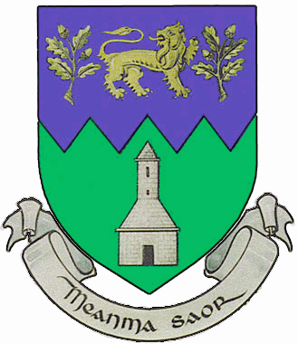

Community Pride

Guidelines

2020

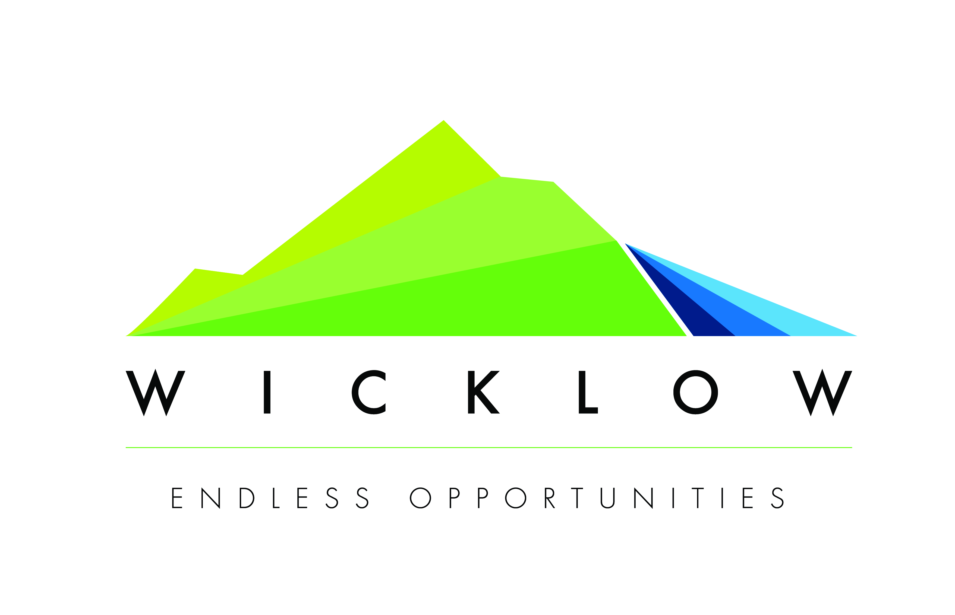

Community Pride Scheme 2020

Ethos and focus of awards

The purpose of the Wicklow County Councils Community Pride Scheme is to support group with LARGE projects that make a significant impact and difference to the lives of the people in their community under the any of the following headings:

- Community Wellbeing
- Community Age Friendly Initiatives
- Community Tourism
- Community Enterprise and Creative Initiatives

A maximum of 5 grants will be awarded under the above categories. The maximum grant available is €10,000.

The Award Scheme gives the County Council the opportunity to recognise and value the voluntary contribution made by local groups in their own localities.

Social inclusion is a central theme of the Programme – Social Inclusion is about focusing on the needs of marginalised and disadvantaged groups such as people with disabilities, the unemployed/low income groups, travellers, homeless, lone parents, gay/lesbian/bi-sexual/transgender community, older people, children/young people, rurally isolated etc.

Applications will not be accepted from statutory bodies. Proposals from individuals will generally not qualify.

Pride of Place 2020

Pride of Place in the Community is a National All-Island competition which is directed towards recognising improvements by local communities to create civic pride in their area. The competition focuses on people coming together to shape, change and enjoy all that is good about their area. It is a unique opportunity for community groups to be officially recognised for the valuable work undertaken in their local areas. Successful applicants may be nominated to represent County Wicklow at the All-Island National Pride of Place competition. Wicklow County Council will support these Community Pride winners to represent Wicklow in the All-Island Pride of Place competition

Appraisal and decision process
A small appraisal committee including representation from the Municipal Districts will consider all applications made under the Community Pride Scheme.

Key considerations in assessing applications will include:

- The strength of the application – it is very important to supply all
information requested on the form
- Social inclusion and anti-racism projects
- Sports participation opportunities for disadvantaged
- The ability of the group to carry out the project
- The impact, scope and inclusiveness of the project.
- Sustainability
- Beneficial if the group adheres to the Governance Code
- Beneficial if your group is a member of the Public Participation Network (PPN)

When will grants be paid?
The grants will be paid out to successful applicants at awards ceremonies to be held in each Municipal District during May/June 2020. Dates to be confirmed.

Closing Date
The closing date for receipt of completed applications is 12 noon on Friday 28th February, 2020.

An original signed copy of the application form must be received prior to the closing date. Fax or email copies are not acceptable. Late applications will not be considered.

Application Process

Completed application forms should be returned to:

The Office of Community, Cultural & Social Development
Wicklow County Council,
County Buildings
Wicklow, Co. Wicklow.

Any queries to Community, Cultural & Social Development. Tel. (0404) 20208 or email: ccsdadmin@wicklowcoco.ie

PLEASE INCLUDE THE FOLLOWING WITH YOUR APPLICATION FORM
APPLICATIONS WILL NOT BE CONSIDERED IF THESE DOCUMENTS ARE NOT SUPPLIED.

Copy of current Bank, Credit Union or An Post statement.
Labhaoise McKenna

Copy of group constitution.

WICKLOW COUNTY COUNCIL
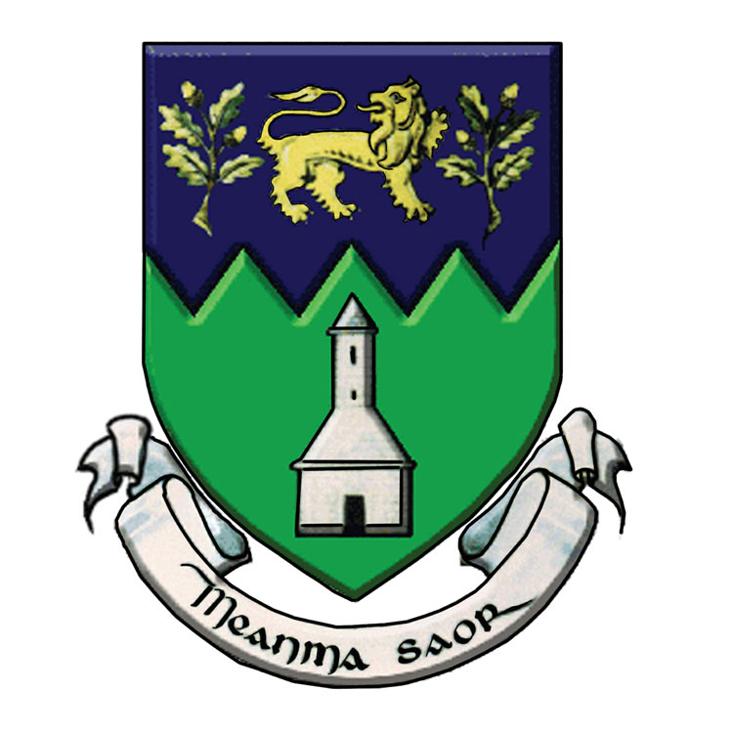
Community pride awards
2020
APPLICATION FORM

Name of Community/Voluntary Group

Category being applied for: -

 Community Wellbeing
 Communities reaching out to new communities
 Community Tourism
 Community Enterprise

Tax Reference Number or Charitable Status (CHY) Number: (if Applicable)

Applicant Details
Name
Address
Position in group:
Eircode
Daytime telephone
Email
Municipal District in which group operates

Number of Voluntary Workers
Number of Paid Workers
How many members are there?
Is membership open?
Details of membership fees

What are the aims, objectives and ethos of your group?

What are the activities of your group?

What is the activity/project for which you are seeking a grant?

How will this activity be managed?

Why is there a need for this activity or action? Please provide support/proof of need or consultation carried out?

Who will benefit from this activity?

Governance Code:
Has your group signed up to the Governance Code?

In the process of signing up?

Is your group a member of the Public Participation Network?

Name of your Group Bank Account: (This is the name that appears on your bank statement).

Outline the estimated cost of the activity or action. €

Amount sought from Wicklow County Council. €

If the amount you are requesting is not the total cost of the proposed activity or action, please advise from where the balance of funds is coming

Have you applied for or received funding from any other source in the last year. If yes, please give details.

DECLARATION:

I declare that all the information given in this form is true and complete to the best of my knowledge and belief. I acknowledge that any funds awarded must be used for the purpose stated.

I also accept as a condition of the grant scheme:

- That it involves no commitment to any other grants from Wicklow County Council in the future.
- Wicklow County Council reserve the right to request further information, if required.
- Wicklow County Council will undertake to review the scheme from time to time and as a result may make any changes necessary without any prior notice and at the Council’s discretion.
- That Wicklow County Council hold no responsibility for the project and that the project must meet with all Planning and Health and Safety Regulations.
- To have the project monitored by Wicklow County Council or by its agents, to allow access to its premises and records, as necessary for that purpose.
- To provide details of the grant spent in the Evaluation Form provided by the 31st December, 2020
- That grant allocation must be used for the project approved and grant monies unspent within the 12 month period must be returned.
- In order to process your application it may be necessary for Wicklow County Council to collect personal data from you. Such information will be processed in line with the Local Authority’s privacy statement which is available to view on Wicklow.ie.

Signed: _________________________ Date: ____________________
CHAIRPERSON

DATABASE

Wicklow County Council is currently preparing a database of Community & Voluntary Groups in the county. This will be used exclusively by WCC to inform groups and organisations (by email)
of any upcoming grants or community news.

If you wish to be included on this database please complete and sign this form:

Name of Community Group ___________________________________

Contact email: ______________________________________________
(Please print)

Contact Name: _______________________________________________

Signature: ________________________________________________

Date: ________________________________________________

